Kamran Gul | CMS: 023-25-0161 | CS AI (C) | Lab # 6

Task 1:
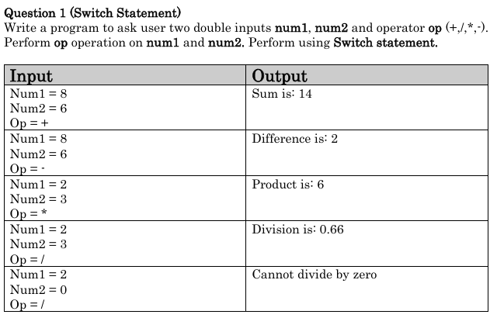
Solution:
#include<iostream>
using namespace std;
int main(){
double num1,num2;
char ch;
cout<<"Enter first number: ";
cin>>num1;
cout<<"Enter second number: ";
cin>>num2;
cout<<"Enter operator: ";
cin>>ch;

switch(ch){
case '+':
cout<<"Sum is "<< num1+num2;
break;
case '-':
cout<<"Difference is "<< num1-num2;
break;
case '*':
cout<<"Product is "<< num1*num2;
break;
case '/':
if(num2==0){
cout<<"Cannot divide by zero";
}
else
cout<<"Division is "<< num1/num2;
break;
}

cout<<endl;
system("PAUSE");
return 0;
}
Output:
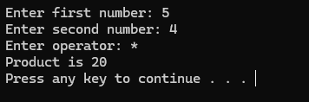

Task 2:
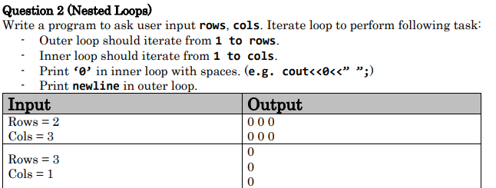
Solution:
#include<iostream>
using namespace std;
int main(){
int rows,cols;
cout<<"Enter rows: ";
cin>>rows;
cout<<"Enter columns: ";
cin>>cols;

for( int i = 1; i<=rows; i++){
for(int j = 1; j<=cols; j++){
cout<<"0 ";}
cout<<endl;
}

cout<<endl;
system("PAUSE");
return 0;
}
Output:
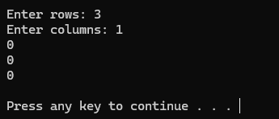

Task 3:
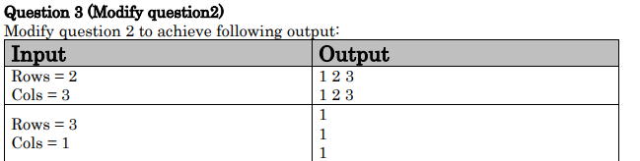
Solution:
#include<iostream>
using namespace std;
int main(){
int rows,cols;
cout<<"Enter rows: ";
cin>>rows;
cout<<"Enter columns: ";
cin>>cols;

for( int i = 1; i<=rows; i++){
for(int j = 1; j<=cols; j++){
cout<<j<<" ";}
cout<<endl;
}

cout<<endl;
system("PAUSE");
return 0;
}
Output:
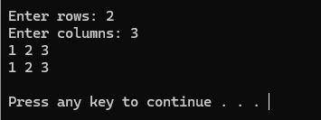

Task 4 (a):
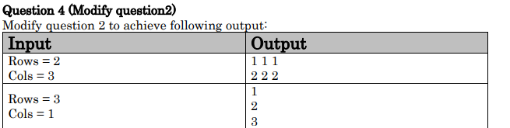
Solution:
#include<iostream>
using namespace std;
int main(){
int rows,cols;
cout<<"Enter rows: ";
cin>>rows;
cout<<"Enter columns: ";
cin>>cols;

for( int i = 1; i<=rows; i++){
for(int j = 1; j<=cols; j++){
cout<<i<<" ";}
cout<<endl;
}

cout<<endl;
system("PAUSE");
return 0;
}
Output:
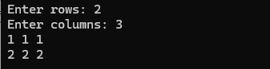

Task 4 (b):
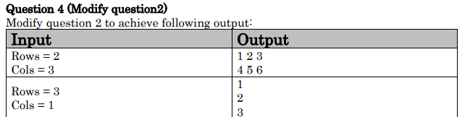
Solution:
#include<iostream>
using namespace std;
int main(){
int rows,cols,i,j,num=1;
cout<<"Enter rows: ";
cin>>rows;
cout<<"Enter columns: ";
cin>>cols;

for(i = 1; i<=rows; i++){
for(j = 1; j<=cols; j++){
cout<<num<<" ";
num++;
}
cout<<endl;
}

cout<<endl;
system("PAUSE");
return 0;
}
Output:
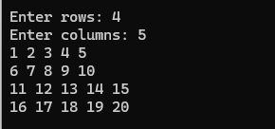

Task 5 (a):
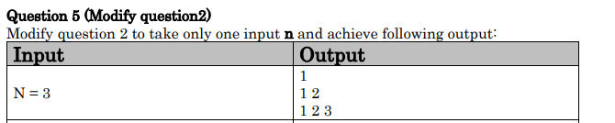
Solution:
#include<iostream>
using namespace std;
int main(){
int rows,cols;
cout<<"Enter number: ";
cin>>rows;

for( int i = 1; i<=rows; i++){
for(int j = 1; j<=i; j++){
cout<<j<<" ";}
cout<<endl;
}

cout<<endl;
system("PAUSE");
return 0;
}
Output:
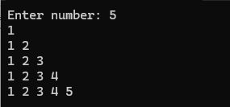

Task 5 (b):
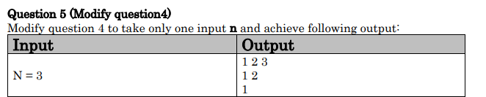
Solution:
#include<iostream>
using namespace std;
int main(){
int rows,cols;
cout<<"Enter number: ";
cin>>rows;

for( int i = rows; i>=1; i--){
for(int j = 1; j<=i; j++){
cout<<j<<" ";}
cout<<endl;
}

cout<<endl;
system("PAUSE");
return 0;
}
Output:
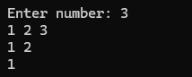

Task 6:
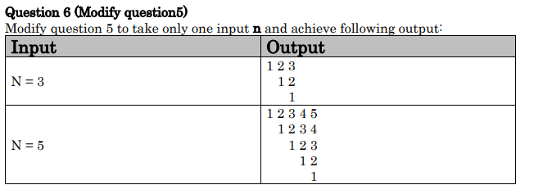
Solution:
#include<iostream>
using namespace std;
int main(){
int rows,cols;
cout<<"Enter number: ";
cin>>rows;

for( int i = 0; i<=rows; i++){

for(int s = 0; s<=i; s++){
cout<<" ";
}
for(int j = 1; j<=rows-i; j++){
cout<<j<<" ";}
cout<<endl;
}

cout<<endl;
system("PAUSE");
return 0;
}
Output:
